STAGE 4
Sum Sense subtraction Factors: Click and drag the digit cards to make a subtraction sum  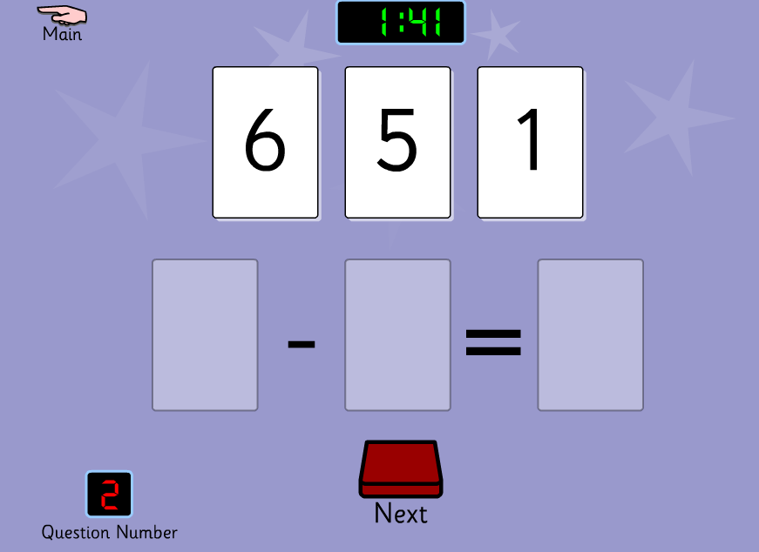 | 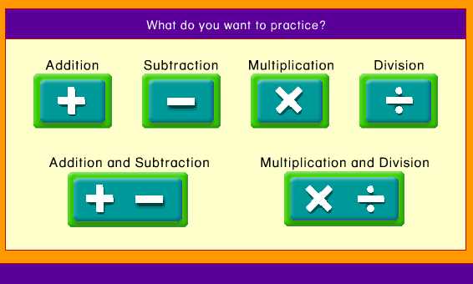 | Play Number 2 Know all bonds to 20  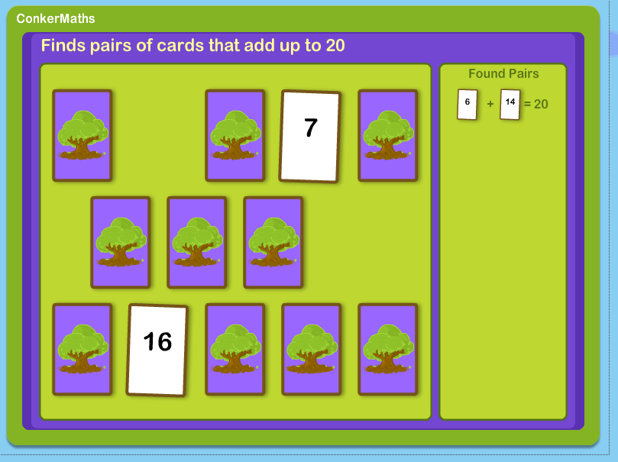
Doubles to 20  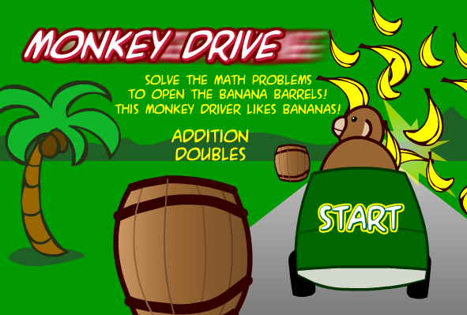 | Subtraction Facts from 20- Play levels 4 or 5 | Make 100 using 10’s and 5’s
Additionn Facts to 20- Play levels 4 or 5  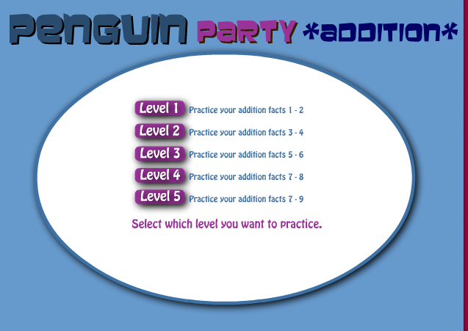 | Multiplication Facts, choose levels 1,2,3  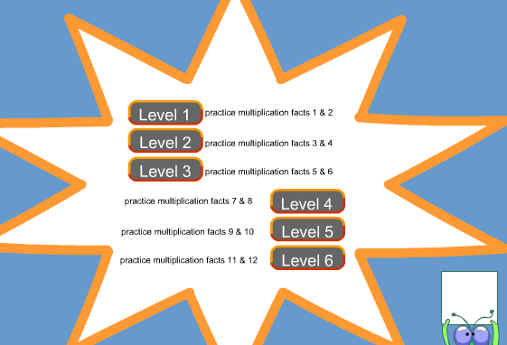 | Robin Hood doubles to 20  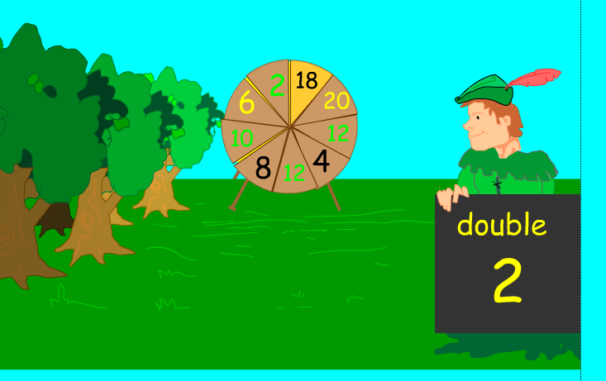

Stage 5
Find the missing 10 patterns from 1000
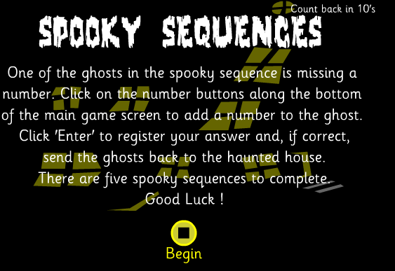
Muliples of 2,5,10  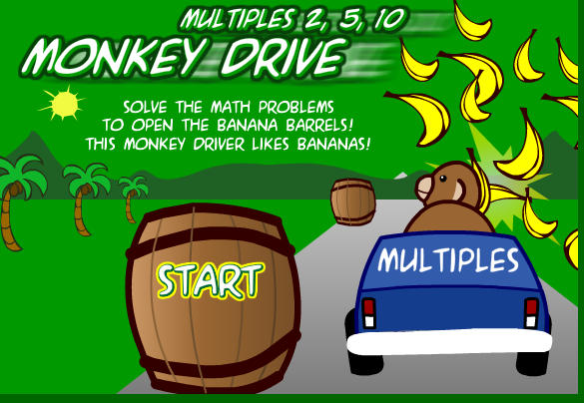 | Subtracting in 10’s from 100  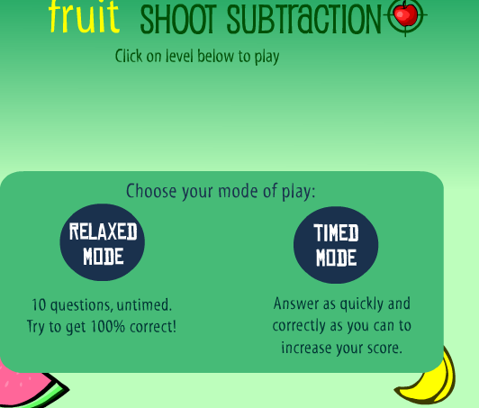 | Play Doubles to 100  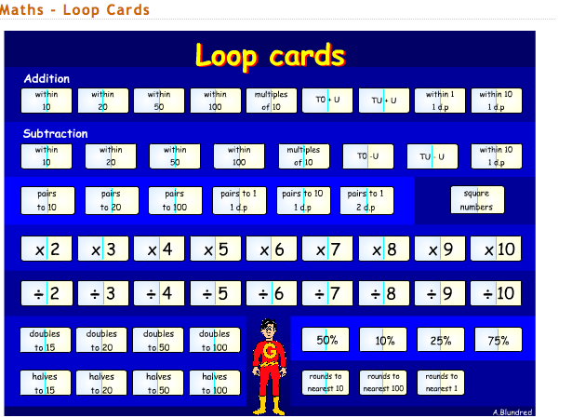
Multiplication Facts, choose levels 3,4,5 | Play Division levels 1, 2  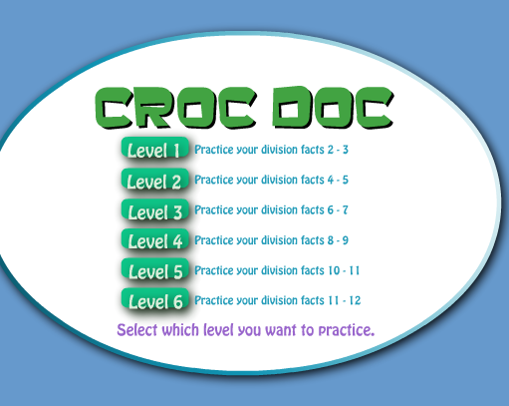 | Make 100 using 10’s and 5’s  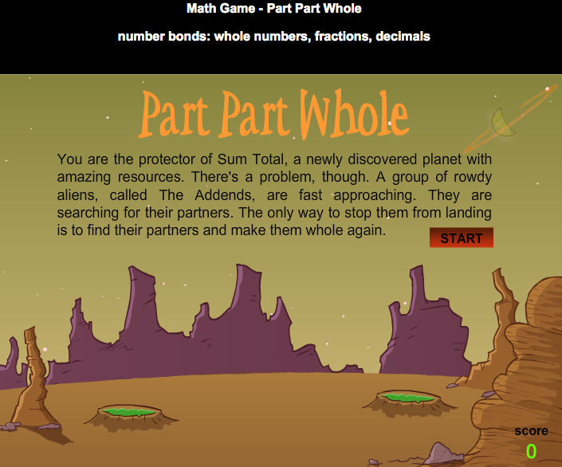

Stage 6
Speed Grid to 100: Click on the tiles to make the correct sum. Timed! Answer 8 questions in 2 minutes.  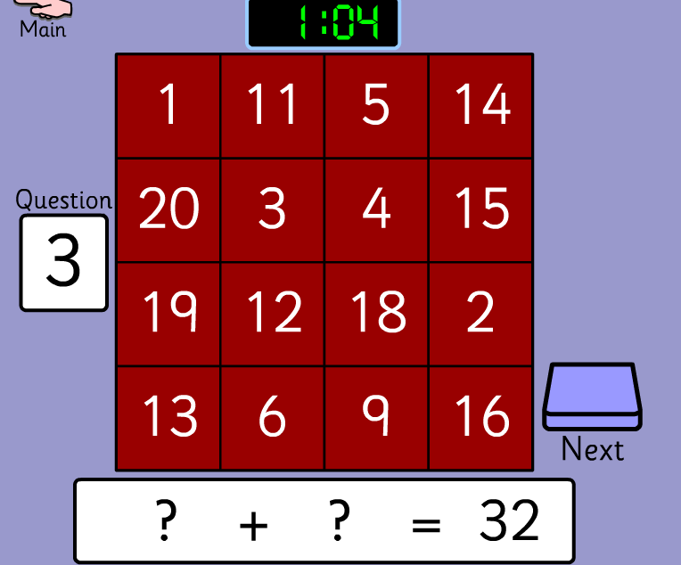 | Sum Sense Multiplication Factors: Click and drag the digit cards to make a multiplication sum  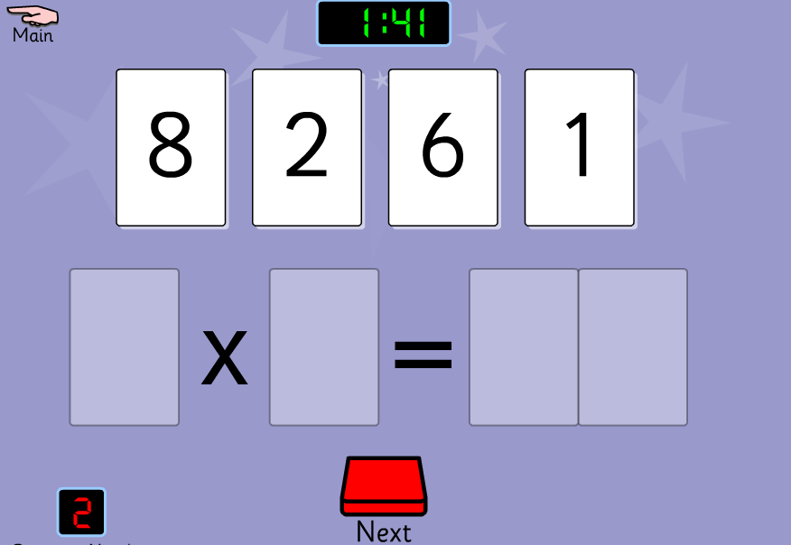 | Division  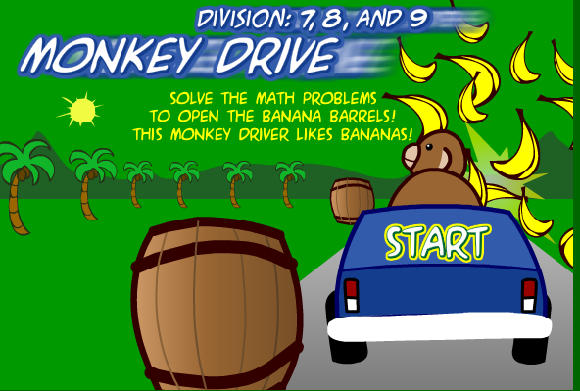
Speed Grid Subtraction to 100 Timed  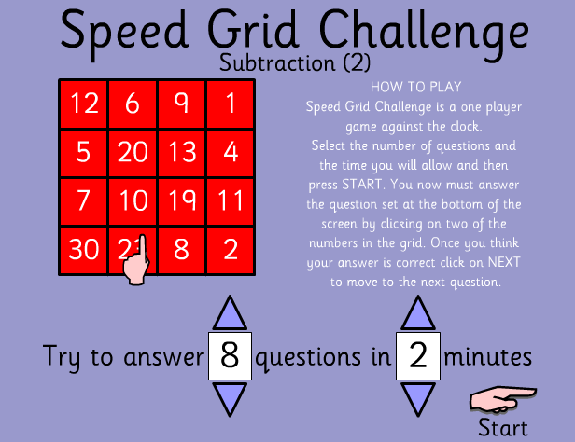 |  | Multiplication Facts, choose Levels 4,5,6
Sum Sense Division Factors: Click and drag the digit cards to make a division sum  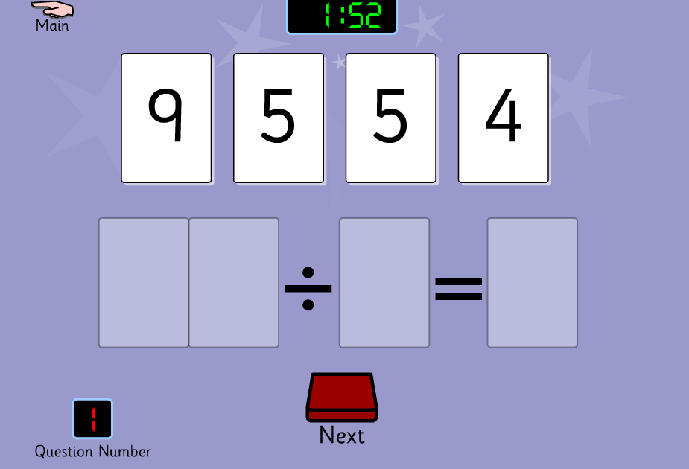 | Division 4,5,6  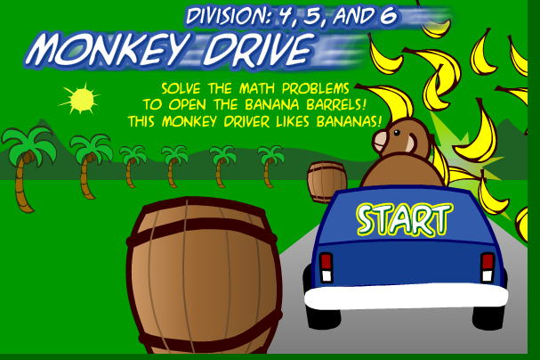 | Make Pairs to 1000  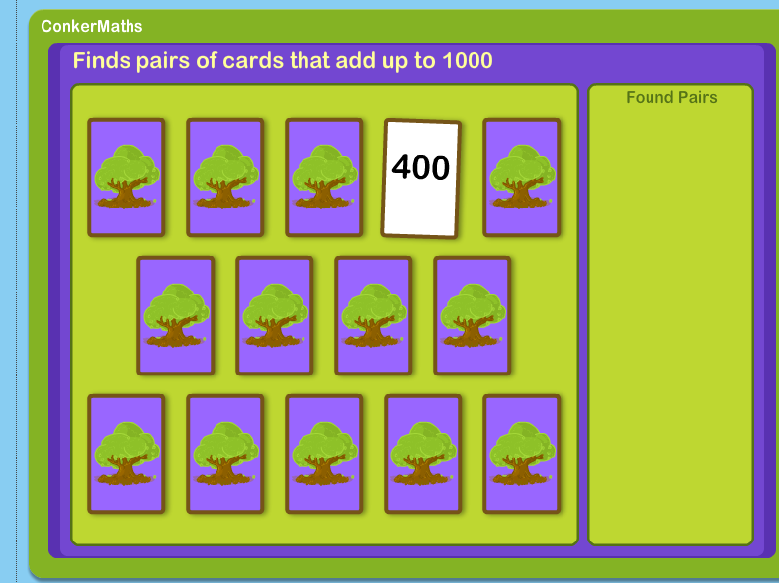

Stage 7
Ordering Decimals with one decimal place  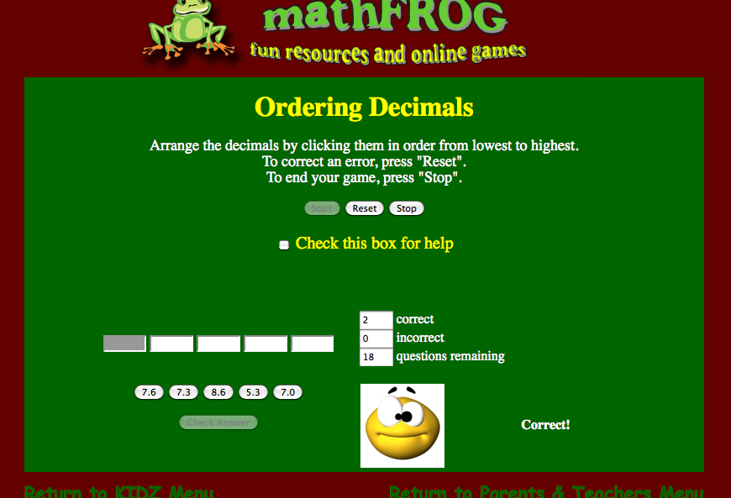 | Adding decimals  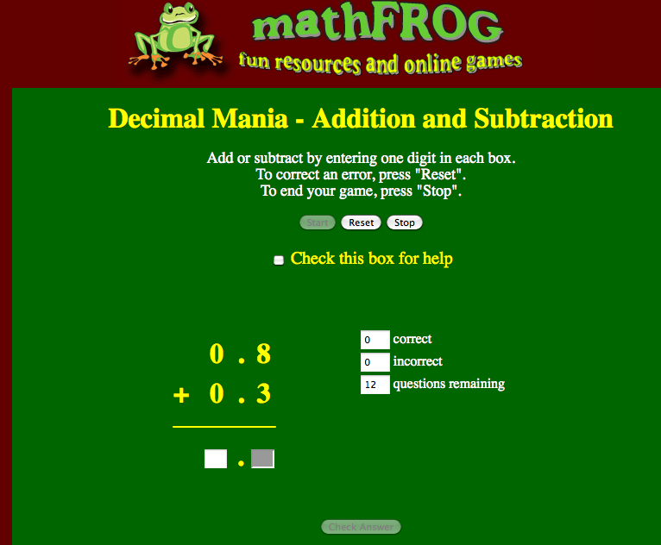 | Find pairs that add to 10 using decimals  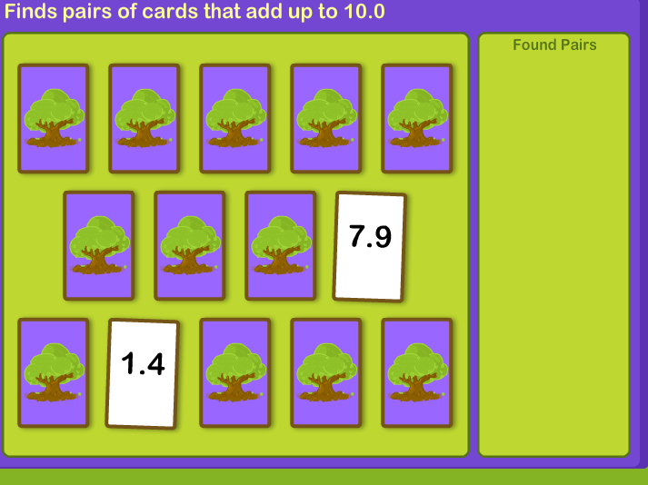
Mulitples of 7,8,9  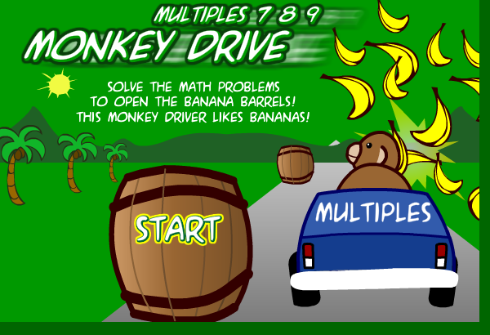 | Find of decimals that add to 1  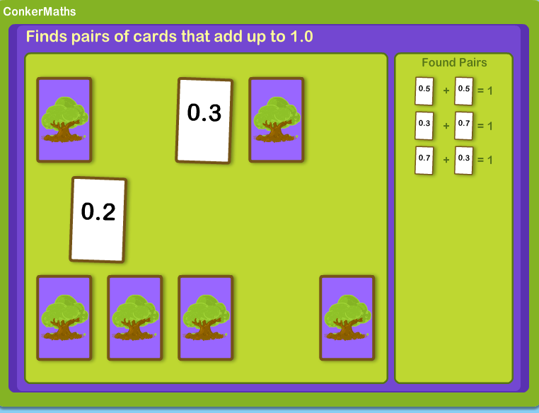 | Integers to 1000: Find the sum of and difference between 2 numbers  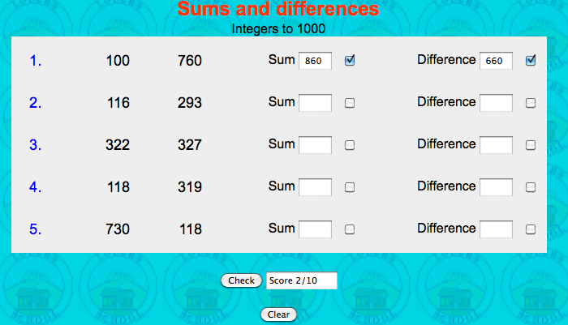
Make 1 using decimals with 1 and 2 decimal places

